**CREATIVE EDUCATIONAL SERVICES**

**BEGINNING OF TERM I EXAMINATIONS 2024**

**RELIGIOUS EDUCATION**

**PRIMARY ONE**

**Name:……………………………………………………Class: ……….………..……**

**School: ………………………………..…………………………..…………………..**

1. **Draw these gifts from God/Allah.**

|  |  |  |  |  |
| --- | --- | --- | --- | --- |
|  |  |  |  |  |
| eyes | trees | man | cow | leg |

1. My religious name is ____________________________________
2. Moslems pray ________________ times a day.
3. **Name these God’s creation.**

|  |  |  |
| --- | --- | --- |
|  | 5 |  |
|  |  |  |

1. Muslims go to _________________ Friday for prayers.
2. Christians go to _________________ on Sunday for prayers.

(church, mosque)

1. **Draw these places of worship.**

|  |  |
| --- | --- |
|  |  |
| mosque | church |

1. **Match parts of the body to their uses.**

eyes feeling

ears walking

nose seeing

tongue hearing

leg smelling

skin tasting

1. **Choose the correct word to fill in the gaps.**

Who cooks at home _______________________________

____________________ heads a family.

Who teaches water at home? _______________________

_____________________ cleans the house.

(brother, mother, sister, father)

1. **Tick ($√$) Muslim names.**

Jackie, Habibah, Aisha, John, Musa

1. **Tick ($√$) Christian names.**

Annet, Cate , Juma, Rita

1. **Match words to pictures.**



clouds

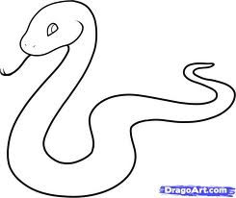

cats



fish

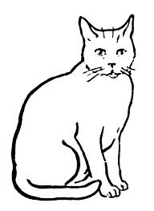

snake



man

1. **Draw these family members.**

|  |  |  |  |
| --- | --- | --- | --- |
|  |  |  |  |
| brother | father | sister | mother |

1. **Name these non living things.**

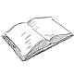

_________ __________ __________

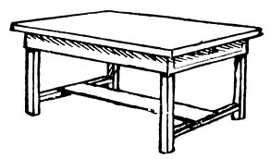

_________ ___________ ___________

1. **Match people at school to their work.**

cooks keeps the gate

teacher heads a school

nurse cook food

head teacher teaches

gate keeper treats sick people

1. **Draw your self praying.**

***“GOOD LUCK”***